Supplementary Information for

High Tunable Refractive Index Visible Light Metasurface from Block Copolymer Self-Assembly

Ju Young Kim, Hyowook Kim, Bong Hoon Kim, Taeyong Chang, Joon Won Lim, Hyeong Min Jin, Jeong Ho Mun,Young Joo Choi, Kyungjae Chung, Jonghwa Shin*, Shanhui Fan, Sang Ouk Kim*

correspondence to: qubit@kaist.ac.kr; sangouk.kim@kaist.ac.kr

This PDF file includes:

Supplementary Figure 1 to 14

Other Supplementary Materials for this manuscript includes the following:

Supplementary Movies 1

Supplementary Figure 1 | SEM images and corresponding Fourier Transformation of nanoparticle arrays before pattern transfer (left), after pattern transfer but before pattern shrinkage (middle), and after pattern shrinkage.

Supplementary Figure 2 | Snap shot images during pattern shrinkage process. Real time images were presented, presenting the color change of Au nanoparticle array from red to blue

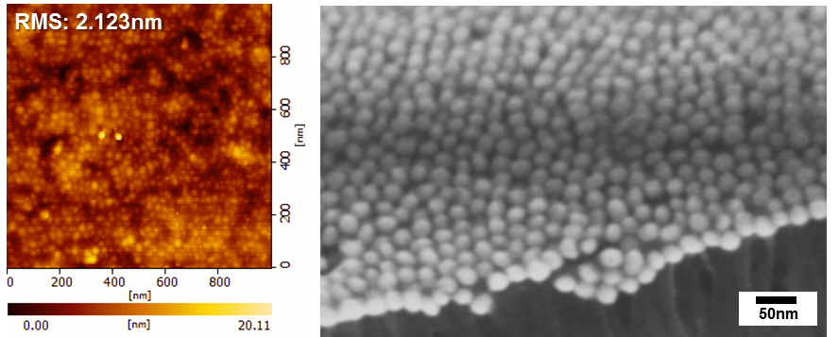
Supplementary Figure 3 | AFM & SEM images of flat structure with nanoparticle array after completion of shrinkage process

Supplementary Figure 4 | a, b, SEM images of Au nanoparticle arrays on silicon substrates before (a) & after (b) thermal annealing at 170 °C for 10 min.

Supplementary Figure 5 | Simulated resonance frequency of nanoparticle ensembles as a function of inter-particle distance

Supplementary Figure 6 | Uniform SERS of Au nanoparticle ensembles prepared from the pattern shrinkage process.

Supplementary Figure 7 | a, Resonance wavelength shift as a function of Au content. b, Figure of merit (FOM = refractive index / extinction coefficient) of each metamaterial.

Supplementary Figure 8 |. a-c, Complex refractive index (a), permittivity (b) and permeability (c) obtained from retrieval method of scattering parameters.

Supplementary Figure 9 | Simulated a, refractive index and b, extinction coefficient for various inter-particle distances. The particle shape is fixed as a truncated spheroid with 26.4 nm major axis, 10.82 nm minor semi-axis, and 16.28 nm height. The lattice is hexagonal with C₆ symmetry.

Supplementary Figure 10 | Polarization dependent refractive index from FDTD calculations of anisotropically coupled Ag nanoparticle ensemble with 1 nm inter-particle distance in x direction.

Supplementary Figure 11 |. Morphological change of nanoparticle arrays with 6-fold symmetry depending on the shrinkage direction and grain orientation. Due to the dependency to shrinkage direction and randomness of BCP grain orientation, anisotropic shrinkage results in the coexistence of complex morphologies of nanoparticle arrays.

Supplementary Figure 12 |. Control experimental for anisotropic elongation of nanoparticle array with sparse inter-particle distance, and its optical responses to polarized light.

Supplementary Figure 13 |. Substrate transfer of nanoparticle ensemble visible metamaterials onto hard or soft substrate. a, b, Schematic illustrations for the transfer onto hard (a) and soft substrate (b). c, d, SEM and photographic images after transfer onto silicon (c) and glass pipet surface (d).

Supplementary Figure 14 |. Area-selective metallic nanoparticle ensembles fabrication. a, b, SEM images of line (a) & complex photoresist (PR) micro-pattern (b) on silicon substrate with Au nanoparticle array. c, d, SEM images of lithographically defined line (c) & complex pattern (d) with Au nanoparticle array after selective wet removal of Au and lift-off of PR. e, f, SEM images after pattern shrinkage of c, d.

